**🎵 Digital Music Store SQL Project**

**Tools**: PostgreSQL, pgAdmin, SQL

**🎯 Project Goal**

Designed and implemented a relational database to simulate a digital music store environment. Imported multiple CSV files into PostgreSQL via pg Admin to populate core tables such as Artist, Album, Track, Playlist, Invoice, and Customer.

* Defined and enforced foreign key relationships to normalize data and maintain referential integrity.
* Developed and executed SQL queries to extract meaningful insights around customer behavior, sales performance, and genre popularity.
* Demonstrated full data life cycle capabilities — from ingestion and modeling to advanced data analysis and insights.

**SCHEMA OF DATA SET**:

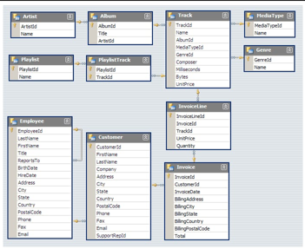

**📊 Query Analysis Levels**

To show progression and skill growth, I categorized SQL queries into three levels of complexity:

* Beginner-Level Queries :

1. Who is the senior most employee based on job title?

2. Which countries have the most Invoices?

3. What are top 3 values of total invoice?

4. Which city has the best customers? We would like to throw a promotional Music Festival in the city we made the most money. Write a query that returns one city that has the highest sum of invoice totals. Return both the city name & sum of all invoice totals.

5. Who is the best customer? The customer who has spent the most money will be declared the best customer. Write a query that returns the person who has spent the most money.

* Intermediate-Level Queries:

1. Write query to return the email, first name, last name, & Genre of all Rock Music. listeners. Return your list ordered alphabetically by email starting with A.

2. Let's invite the artists who have written the most rock music in our data set. Write a query that returns the Artist name and total track count of the top 10 rock bands.

* Advanced-Level Queries:

1. Find how much amount spent by each customer on artists? Write a query to return customer name, artist name and total spent.

2. We want to find out the most popular music Genre for each country. We determine the most popular genre as the genre with the highest amount of purchases. Write a query that returns each country along with the top Genre. For countries where the maximum number of purchases is shared return all Genres.

**SQL Queries:**

* Beginner-Level Queries :

1. Who is the senior most employee based on job title?

SELECT *   
 FROM Employee   
 ORDER BY levels DESC   
 LIMIT 1;

Output:  


2. Which countries have the most Invoices?

select count(*) as c,billing_country

from invoice

group by billing_country

order by c desc

limit 5;

Output:

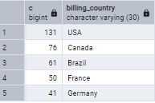

3. What are top 3 values of total invoice?

select total from invoice

order by total desc

limit 3;

Output:

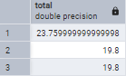

4. Which city has the best customers? We would like to throw a promotional Music Festival in the city we made the most money. Write a query that returns one city that has the highest sum of invoice totals. Return both the city name & sum of all invoice totals.

select sum(total) as invoice_total,billing_city

from invoice

group by billing_city

order by invoice_total desc

limit 3;

Output:



5. Who is the best customer? The customer who has spent the most money will be declared the best customer. Write a query that returns the person who has spent the most money.

select customer.customer_id,customer.first_name,customer.last_name,sum(invoice.total) as total

from customer

join invoice on customer.customer_id = invoice.customer_id

group by customer.customer_id

order by total desc

limit 1;

Output:



* Intermediate-Level Queries:

1. Write query to return the email, first name, last name, & Genre of all Rock Music. listeners. Return your list ordered alphabetically by email starting with A.

select distinct email,first_name,last_name

from customer

join invoice on customer.customer_id = invoice.customer_id

join invoice_line on invoice.invoice_id = invoice_line.invoice_id

where track_id in(

select track_id from track

join genre on track.genre_id=genre.genre_id

where genre.name like 'A%'

)

order by email

limit 5;

Output:

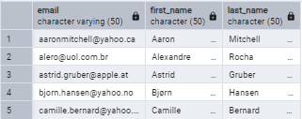

2. Let's invite the artists who have written the most rock music in our data set. Write a query that returns the Artist name and total track count of the top 10 rock bands.

select artist.artist_id,artist.name,count(track.track_id) as no_of_songs

from track

join album on album.album_id = track.album_id

join artist on artist.artist_id=album.artist_id

join genre on genre.genre_id =track.genre_id

where genre.name ilike 'rock'

group by artist.artist_id

order by no_of_songs desc

limit 5;

Output:

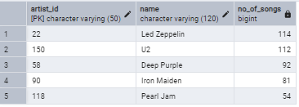

3. Return all the track names that have a song length longer than the average song length. Return the Name and Milliseconds for each track. Order by the song length with the longest songs listed first.

select name,milliseconds

from track

where milliseconds > (

select avg(milliseconds) as avg_track_length from track)

order by milliseconds desc

Limit 3;

Output:

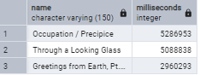

* Advanced-Level Queries:

1. Find how much amount spent by each customer on artists? Write a query to return customer name, artist name and total spent.

WITH best_selling_artist AS (

SELECT

ar.artist_id,

ar.name AS artist_name,

SUM(il.unit_price * il.quantity) AS total_sales

FROM invoice_line il

JOIN track t ON t.track_id = il.track_id

JOIN album al ON al.album_id = t.album_id

JOIN artist ar ON ar.artist_id = al.artist_id

GROUP BY ar.artist_id, ar.name

ORDER BY total_sales DESC

LIMIT 1

)

SELECT

c.customer_id,

c.first_name,

c.last_name,

bsa.artist_name,

SUM(il.unit_price * il.quantity) AS amount_spent

FROM invoice i

JOIN customer c ON c.customer_id = i.customer_id

JOIN invoice_line il ON il.invoice_id = i.invoice_id

JOIN track t ON t.track_id = il.track_id

JOIN album alb ON alb.album_id = t.album_id

JOIN best_selling_artist bsa ON bsa.artist_id = alb.artist_id -- Filter only best-selling artist

GROUP BY c.customer_id, c.first_name, c.last_name, bsa.artist_name

ORDER BY amount_spent DESC

limit 5;

Output:

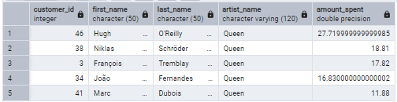

2. We want to find out the most popular music Genre for each country. We determine the most popular genre as the genre with the highest amount of purchases. Write a query that returns each country along with the top Genre. For countries where the maximum number of purchases is shared return all Genres.

with popular_genre as(

selectcount(invoice_line.quantity)as purchase,customer.country,genre.name,genre.genre_id,

row_number()over(partition by customer.country order by count(invoice_line.quantity)desc) as Rowno

from invoice_line

join invoice on invoice.invoice_id=invoice_line.invoice_id

join customer on customer.customer_id=invoice.customer_id

join track on track.track_id = invoice_line.track_id

join genre on genre.genre_id=track.genre_id

group by 2,3,4

order by 2 asc,1 desc

)

select * from popular_genre where Rowno<=1

limit 5;

Output:

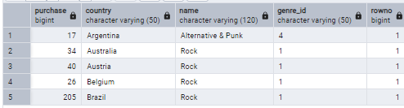

This project enhanced my SQL skills through real-world data analysis.  
I extracted key insights on customer spending, sales trends, and genre popularity.  
It demonstrates my ability to manage data from import to insight generation.